

SIMATS ENGINEERING

Saveetha Institute of Medical and Technical Sciences
Chennai- 602105

Student Name: S Yuva Guru Mani Varma Reg. No.: 192425005
Course Code: ITA0402 Slot: B
Course Name: Statistics With R Programming
Course Faculty: Dr. Jaithunbi A K
Project Title: Predict Solar Output Using Time Series & Machine Learning Techniques
Module Photographs: (3 photographs –Module Photo, Individual student contribution module work in the project and presentation image)
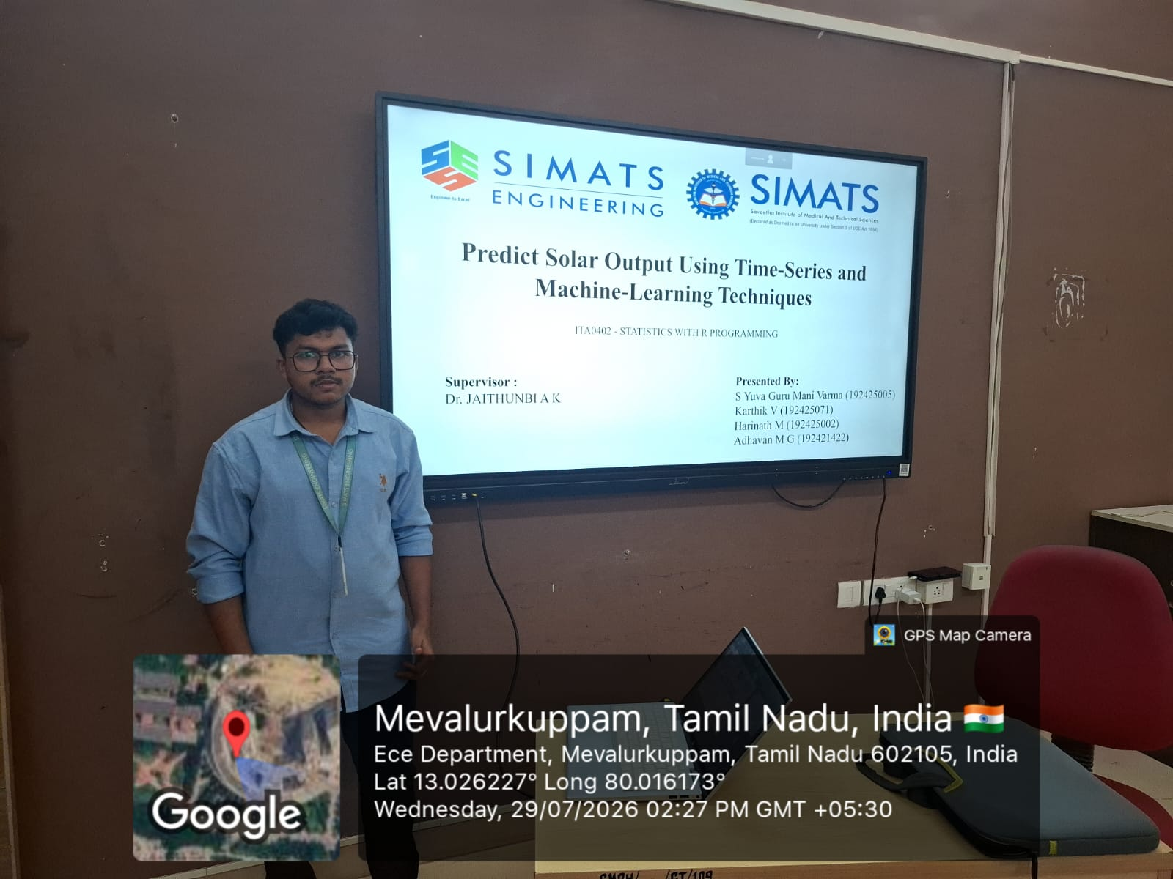
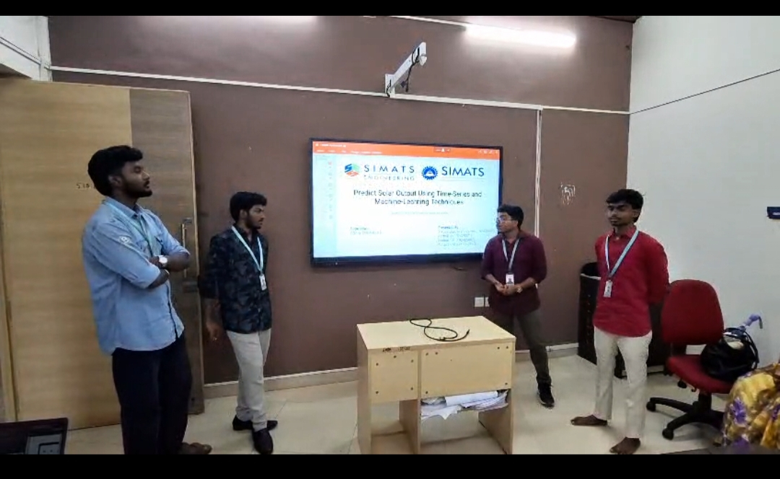
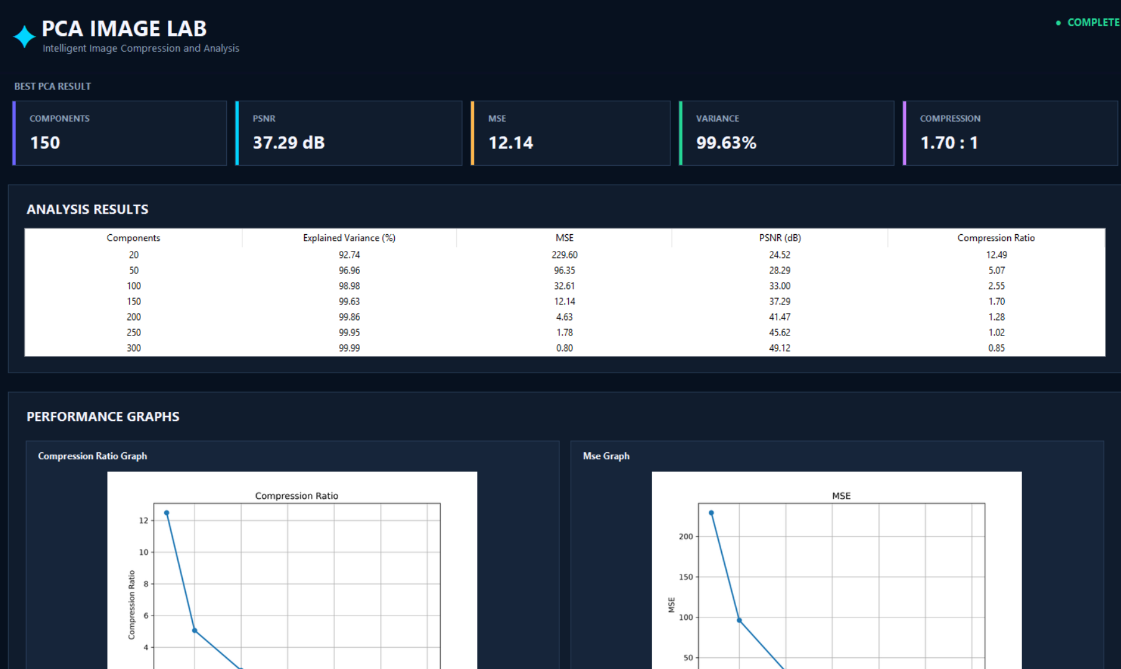
Project Description:
Renewable energy plays an important role in meeting the increasing demand for clean and sustainable power. Among renewable sources, solar energy is widely used, but its power generation varies continuously due to changing environmental and weather conditions. Factors such as solar radiation, temperature, and humidity can significantly influence the amount of solar energy produced.
Therefore, accurately predicting future solar energy output is important for efficient energy planning, scheduling, and utilization.
This project focuses on developing an R-based solar energy forecasting system that predicts future solar energy generation using historical solar energy and weather data. The system begins by collecting and preprocessing the required datasets. Data preprocessing includes cleaning the data, handling missing values, removing inconsistencies, and preparing the data in a suitable format for analysis and model development.

Student Signature Guide Signature

